DESCRIPTION OF THE PROPOSED PROGRAMME
This template is for 4MOST COMMUNITY SURVEY PROPOSALS.

The full text must be 9 pages or less (longer documents will be rejected), distributed as follow:
- Scientific Rationale and Immediate Objectives: max 3p + max 2p for figures
- Survey type justification: max 1p
- Survey metrics: max 3p

The following settings should not be modified for the main text:
- Margins set to 2.5cm (top), 1.5cm (bottom, left, right)
- Font of the main text set to Arial, 10pt
- Spacing set to 0pt before a paragraph, 5pt after a paragraph

A- Scientific Rationale & Immediate Objectives

Discuss the scientific background of the project; state what are the scientific objectives of the survey. It would be beneficial to put the proposed survey in the international context of past, present and future surveys.

Replace this text by your justification (you can remove all the text in black ink).
Lorem ipsum dolor sit amet, consectetur adipiscing elit. Proin sit amet rhoncus nunc. Integer accumsan aliquam ipsum. Sed et purus pharetra, luctus enim ut, tempor ex. Pellentesque pharetra euismod cursus. Donec a est nisl. Nulla facilisi. Cras quis leo et lorem fermentum bibendum. Nunc volutpat, libero tristique molestie ornare, elit lorem venenatis magna, at tincidunt nulla est sed ante. Curabitur at dolor et nulla sagittis facilisis eget et nibh.
Lorem ipsum dolor sit amet, consectetur adipiscing elit. Proin sit amet rhoncus nunc. Integer accumsan aliquam ipsum. Sed et purus pharetra, luctus enim ut, tempor ex. Pellentesque pharetra euismod cursus. Donec a est nisl. Nulla facilisi. Cras quis leo et lorem fermentum bibendum. Nunc volutpat, libero tristique molestie ornare, elit lorem venenatis magna, at tincidunt nulla est sed ante. Curabitur at dolor et nulla sagittis facilisis eget et nibh.
Fusce velit metus, laoreet nec viverra ac, sollicitudin viverra augue. Vivamus dignissim rhoncus lorem ac sollicitudin. Praesent consequat ipsum ac nunc luctus sollicitudin a et metus. Nam consequat lacus quis diam venenatis scelerisque. Proin dapibus urna ullamcorper massa porttitor, id semper metus venenatis. Interdum et malesuada fames ac ante ipsum primis in faucibus. Mauris eget congue odio, quis placerat urna.

References
The references can use a smaller font (eg 8pt). A suitable format can be generated by ADS using the following custom format: %z0%3i (%Y) "%T," %q, %V, %p ---What follows is an example, not a strict guideline.
1. Kuijken, K., et al. (2015) "Gravitational lensing analysis of the Kilo-Degree Survey, " MNRAS, 454, 3500 -- 2. de Jong, J. T. A., et al. (2015) "The first and second data releases of the Kilo-Degree Survey, " A&A, 582, A62 -- 3. Sobral, D., et al. (2015) "Evidence for PopIII-like Stellar Populations in the Most Luminous Lyman-&alpha; Emitters at the Epoch of Reionization: Spectroscopic Confirmation, " ApJ, 808, 139 -- 4. Massey, R., et al. (2015) "The behaviour of dark matter associated with four bright cluster galaxies in the 10 kpc core of Abell 3827, " MNRAS, 449, 3393 -- 5. Le Fevre, O., et al. (2015) "The VIMOS Ultra-Deep Survey: ~10 000 galaxies with spectroscopic redshifts to study galaxy assembly at early epochs 2 < z < 6, " A&A, 576, A79 -- 6. Smette, A., et al. (2015) "Molecfit: A general tool for telluric absorption correction. I. Method and application to ESO instruments, " A&A, 576, A77 -- 7. Grazian, A., et al. (2015) "The galaxy stellar mass function at 3.5 &le;z &le; 7.5 in the CANDELS/UDS, GOODS-South, and HUDF fields, " A&A, 575, A96 -- 8. Bacon, R., et al. (2015) "The MUSE 3D view of the Hubble Deep Field South, " A&A, 575, A75

This section A should be 3p or less.

Figures

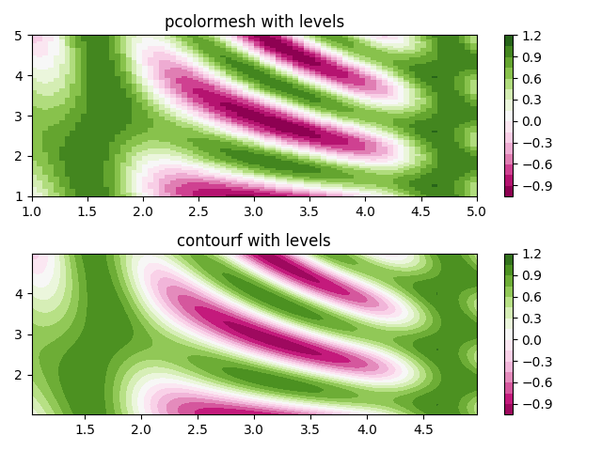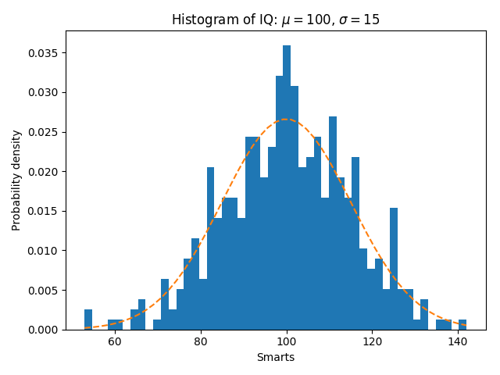
Fig.1 (left) This is the caption of the first figure. This plot is just an example illustrating the power of Python’s Matplotlib package. Fig.2 (right). Feel free to use a Table to structure the plots and captions.

Fig.3 (left) This is the caption of the next figure. More of the same. Fig.2 (right). Feel free to use a Table to structure the plots and captions.

You can have up to 2p of figures.

B- Survey type justification
Discuss the choice of survey type. If Participating elaborate on the scientific synergies and advantages of sharing the focal plane, and on the proposing team plans to contribute to the 4MOST Working Groups. If Non-Participating describe the scientific motivation and advantages of this choice. See also the Survey Policies webpage.

C- Survey Metrics
This section should include the following standard information to facilitate the work of the PSP. It must be 3 pages or less

Replace this text by your justification (you can remove all the text in black ink).

Targets density as a function of RA & Dec.
Please see the example plot form the “4MOST Survey Strategy Plan”
Example:

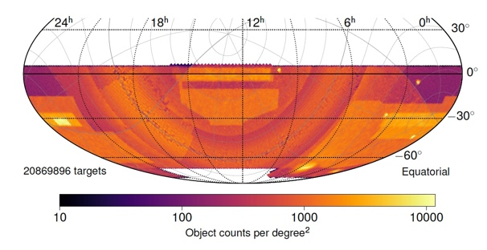

Targets distribution as a function of RA
Please provide the histogram with the following specifications:
- RA bin width: 1 hour
- Separated histograms for LR and HR
- Please see the example plot form the “4MOST Survey Strategy Plan”

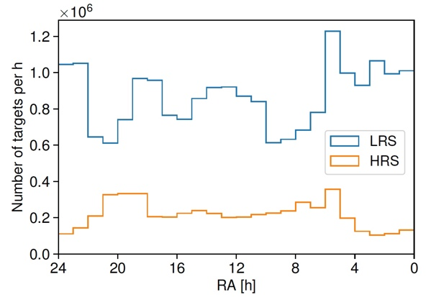

Targets distribution as a function of magnitude
Please provide the histogram with the following specifications:
- Use either G band GAIA magnitude (Vega) or Cousins R band magnitude (AB)
- Bin in magnitude: 0.1 mag
- Separated histograms for HR and LR
- Please see the example plot below:

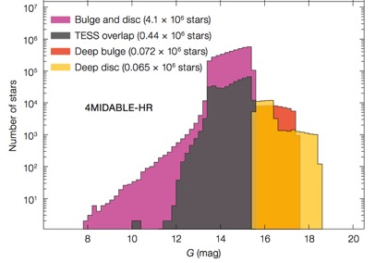

Survey table
Please use the following columns:

Survey Regions | RA  (deg) | Dec  (deg) | Area  (Deg2) | Spectrograph  (Lrs/Hrs) | Range of Targets Density (Targets/Deg2) | Range and Average Texp  (Hours) | Magnitude Range | Execution Priority | Spectral Success Criteria

Table Notes:
- Survey regions: a contiguous patch of the sky covered by the survey (e.g. COSMOS field, or a single stellar cluster)
- Magnitude range: G band GAIA magnitude (Vega) or Cousins R band (AB)
- Execution priority: the relative priority of the execution of a survey region over the other regions of the same survey along the 5 years survey time.
- Spectral Success Criteria: SNR are expected to be provided in this column, if there is the need of a different spectral success criteria please clearly explain it and justify it

Figure of Merit of the survey
Here the survey Figure of Merit should be described. See the 4MOST Facility Simulator User Manual for further information.

Scope of Survey
Here the final output of the Scope of Survey (SoS) calculation obtained from the 4MOST Web Interface should be reported. Please, follow the detailed instructions on the 4MOST Facility Simulator User Manual, on how to generate the SoS, push the submit button on 4FS Web Inerface to upload the final SoS simulation belonging to the proposal and to retrieve the output to be inserted in this section.

